Project From Moonshot to Mars
Plan of Approach

[Authors]
[Date]
[Version]



1. Organisation Structure
In the period of running the From Moonshot to Mars Project, there will be a temporary organisation:

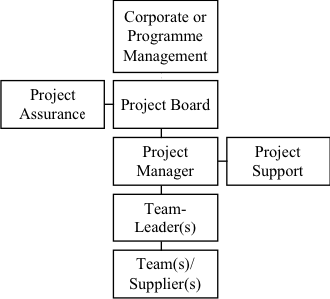
Corporate or Programme Management
Name | Role/Responsibility
Oscar Koeroo | Client

Our client Oscar Koeroo is the client of this project. Mr Koeroo is client on behalf of NIKHEF (The Dutch Institute for Subatatomic Physics) in Amsterdam.

Project Assurance
Name | Role/Responsibility
Sebastiaan Groot | Internal Team Coordinator
Koen Veelenturf | Internal Quality Assurance

During this project, the team will not get any Quality Assurance from ITopia, but will be responsible for their own Quality Assurance. The Project Assurance is responsible for monitoring the quality aspects of the project and the deliverables. The Project Assurance is independent from the Project Manager. The Project Assurance will keep the project in scope and makes sure that the goals will be achieved. The Project Assurance will report to the Project Manager.

Project Manager / Project Board
Name | Role/Responsibility
Sebastiaan Groot | Team Coordinator a.k.a. Project Manager

The Project Manager is responsible for the daily activities of the Project Team. The Project Manager is allowed to make decisions within the boundaries of the Project Board. The main responsibility of the Project Manager is to ensure the deliverables will be deliverd in time, within budget and according to the quality standards.

Project Team
Name | Role/Responsiblity
Remy Bien
Ruben Bras
Sebastiaan Groot | Team Coordinator
Marvin Hiemstra
Wouter Miltenburg
Koen Veelenturf | Internal Quality Assurance

The team is responsible for delivering the products according to specifications, described by the Client and Project Manager. The team reports to the Team Coordinator; the Team Coordinator reports to the Client and the (Hogeschool van Amsterdam) Project Board.

